# Results and evaluation

## Introduction to results

In this project we integrated multiple methods we learned from the learning outcome of this semester, first we used multiple microcontrollers each with its own characteristics, and we used multiple communication methods, and most importantly we integrated many computational libraries to manipulate the data input and output it to the network.

## Presentation of results

### Key findings

The outcome of this project was evaluated based on different criteria:

* Data accuracy:  
  the data accuracy represents the percentage of the usable data gathered from the IMU sensors we have.
* System performance:  
  we faced some limitation to integrate the different methods on different platforms like “Wokwi”, “TinkerCad”, “ViltualBox”.
* Reliability:  
  we found that the protocols are sometimes unreliable because of connection limitations so we had to search and choose other options rather than going with unified work.

### quantifiable metrics

* While gathering the data we recorded the following readings form the IMU sensor:

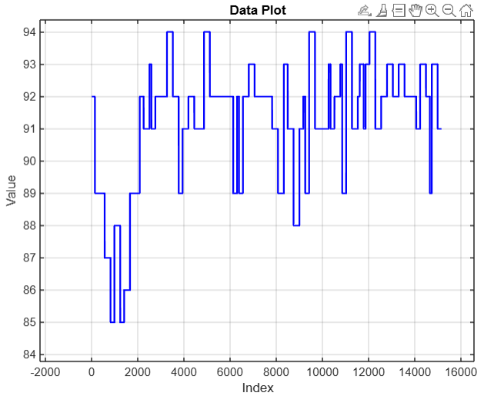

* With comparing and monitoring of data transportation we noticed that the system demonstrated an average response time of 200ms in the best cases with an accuracy of 95% for motion detection.

## Comparison of objectives

* We talked previously about the objectives of this project being the following:

**Remote Control of Robotic Arm  
Integration of Data Inputs  
Real-Time Feedback  
Addressing Doctor Unavailability  
Gesture Control  
Patient Monitoring  
Data Processing and AI Insights  
Optimized System Communication  
Safety and Reliability  
Overcome Technical Challenges**

* In this project we accomplished the remote control of the motor, and we met expectations when talking about the integration of data inputs as well as the gesture control alongside the safety and reliability. While on the other hand, our work wasn’t enough when talking about communication and optimization of system communication.

## Limitations or challenges encountered

* Connection limitations
* Networking complexity
* Lack of resources to fund the whole project
* Lots of errors when dealing with the IMU sensor
* Unavailability of a driver for the motors (considering the stepper motor choice) that can handle the big number of motors to control one or both hands
* Inaccuracy of the stepper motor when dealing with small angles.

# Future work opportunities

## Enhancements to Current System

* On the sensor level, we can better design the location of the sensors on the hand to reach the optimal case cost and performance wise.
* On data computation wise, we can move the Ai model to a computer to get enhanced results
* We can use a higher definition camera
* We can use a server dedicated to communication to ensure good connection
* We can search for better motors and robotic arm design to have better response and grip.

## Expanding Scope

* This project has a very wide range of integration options, as we mentioned before, it can be used by a doctor, inside a chemistry lab, and even by NASA.
* We can merge two systems together. In the planning phase for this project we had two options, to integrate the motion detector by camera, or to use the sensors. And we decided to choose the IMU sensors since they are more accurate and more easier to lay hands on, but in the future we might integrate the two systems together to form a environment that detects the movement of the hand with sensor values and correct it with the camera feedback.
* We can use this technology anywhere and everywhere.

## Research Directions

* After this we are going to focus on searching for a better working protocol, and better communication methods.
* Better motors
* Alternatives of the multiple vital sensors

## Practical Applications

The robotic arm has a wide range of practical applications across multiple domains. In manufacturing, it can be used for assembly lines, material handling, and enhance efficiency and precision.

In biomedical domain, it could assist with delicate surgeries or rehabilitation exercises. The arm could also be integrated into logistics for sorting and packaging tasks, improving safety.

Additionally, its adaptability makes it suitable for research and development. With further refinement, the robotic arm could be a new solution for automation in many places.

# Criteria to Advance in the Project

## Performance Metrics

## System Integration

## Testing and Validation

## Collaboration and Resources

# Conclusion

## Summary of Achievements

## Significance of Work

## Reflection on Learning

## Closing Statement